

Lab Report
on
DATA SCIENCE (3270522)

SUBMITTED BY
Neelesh Ranpuriya 0901AD231042
V Semester
Artificial Intelligence and Data Science

SUBMITTED TO

Dr. Anurag Singh Tomar
Assistant Professor
Dr. Neelam Aarya
Assistant Professor

CENTRE FOR ARTIFICIAL INTELLIGENCE
Madhav Institute of Technology & Science
Gwalior - 474005 (MP)
Session: Jan-June 2025
Table of Contents

Exp. No | Title | Date | Signature
1 | Learn and explore NumPy, Pandas, etc., for numerical computation and data manipulation
2 | Write Python code to calculate mean, median, mode, variance, standard deviation, skewness, and kurtosis.
3 | Create visualizations to detect outliers and understand variable relationships.
4 | Write a program to apply ordinal encoding techniques on categorical data.
5 | Write a program to scale data using normalization and standardization methods.
6 | Build a linear regression model and evaluate using R², MSE, and RMSE.
7 | Perform binary classification and evaluate accuracy, sensitivity, and specificity.
8 | Build a decision tree model for multi-class classification using feature selection techniques.
9 | Implement the K-means algorithm to cluster unlabeled data.
10 | Apply DBSCAN clustering and explain how it detects outliers.

Experiment No. 1

Aim: Study of data science libraries such as Numpy, Pandas etc. for Numerical computations and data manipulation.

Code:
import numpy as np
import pandas as pd

arr_1d = np.array([10, 20, 30, 40, 50])
print(f"1D Array (Vector): {arr_1d}")

arr_2d = np.array([[1, 2, 3], [4, 5, 6], [7, 8, 9]])
print("2D Array (Matrix):\n", arr_2d)

arr_add = arr_2d + 10
print("Array after adding 10 to all elements:\n", arr_add)

arr_sqrt = np.sqrt(arr_1d)
print(f"Square root of 1D Array: {arr_sqrt}")

data = {
'Name': ['Mohit', 'Arman', 'Depanshu', 'Aditya'],
'Age': [19, 21, 20, 21],
'City': ['Chhindwara', 'Guna', 'Jabalpur', 'Panna'],
'Salary': [15000, 25000, 18000, 110000]
}
df = pd.DataFrame(data)
print("Initial DataFrame:\n", df)

filtered_df = df[df['Age'] > 30]

# Creating a new column
df['Tax_Rate'] = 0.15
df['Net_Salary'] = df['Salary'] * (1 - df['Tax_Rate'])
print("\nDataFrame with new calculated column:\n", df[['Name', 'Salary', 'Net_Salary']])

avg_salary = df['Salary'].mean()
print(f"\nAverage Salary in the dataset: ${avg_salary:,.2f}")

Output:
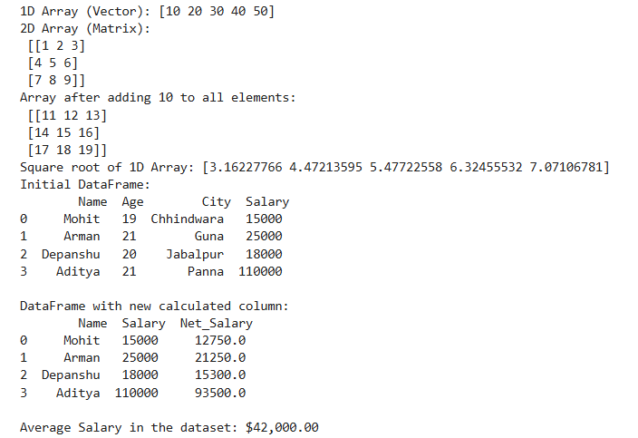

Experiment No. 2

Aim: Write a python program to perform descriptive statistics such as Central Tendency Measures (Mean, Median and Mode), Measure of Dispersion (Variance, Standard Deviation), Skewness and Kurtosis.

Code:
import pandas as pd
import numpy as np
from scipy.stats import skew, kurtosis

data = {
'Score': [85, 92, 78, 88, 95, 75, 80, 88, 90, 85, 85, 100],
'Hours_Studied': [5, 7, 3, 6, 8, 4, 5, 6, 7, 5, 5, 9],
'Gender': ['F', 'M', 'M', 'F', 'F', 'M', 'F', 'M', 'F', 'M', 'M', 'F']
}
df_stats = pd.DataFrame(data)
numerical_col = 'Score'

print(f"Analyzing Descriptive Statistics for the column: '{numerical_col}'\n")

mean = df_stats[numerical_col].mean()
median = df_stats[numerical_col].median()
mode = df_stats[numerical_col].mode()

print(f"Mean (Average): {mean:.2f}")
print(f"Median (Middle Value): {median:.2f}")
print(f"Mode (Most Frequent): {mode.tolist()}")

variance = df_stats[numerical_col].var()
std_dev = df_stats[numerical_col].std()
range_val = df_stats[numerical_col].max() - df_stats[numerical_col].min()

print(f"\nVariance: {variance:.2f}")
print(f"Standard Deviation: {std_dev:.2f}")
print(f"Range: {range_val:.2f}")

skewness = df_stats[numerical_col].skew()
kurtosis_val = df_stats[numerical_col].kurt()

print(f"\nSkewness (Shape of Distribution): {skewness:.2f}")
print(f"Kurtosis (Tail Heaviness/Peakedness): {kurtosis_val:.2f}")

print("\n--- Summary using df.describe() ---")
print(df_stats[numerical_col].describe())

Output:
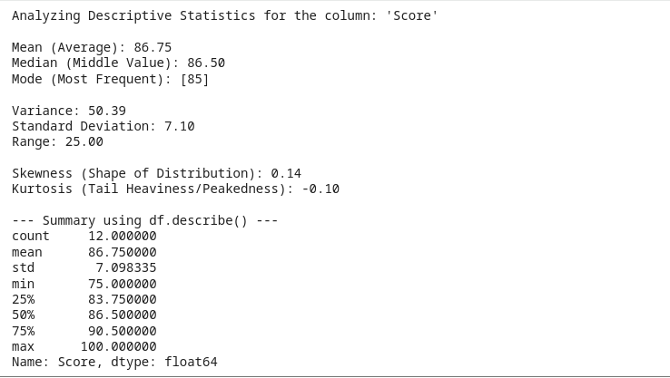

Experiment No. 3

Aim: Write a program to Create visualizations (box plots, scatter plots) to identify outliers and relationships between variables.

Code:
import pandas as pd
import matplotlib.pyplot as plt
import seaborn as sns
import numpy as np

np.random.seed(42)
data_vis = pd.DataFrame({
'Experience': np.arange(1, 101),
'Salary': 50000 + 1500 * np.arange(1, 101) + np.random.normal(0, 10000, 100),
'Age': np.random.randint(22, 60, 100),
# Add an outlier
'Score': np.concatenate((np.random.normal(75, 5, 95), [10, 120, 105, 5, 130]))
})

plt.style.use('seaborn-v0_8-whitegrid')

plt.figure(figsize=(8, 6))
sns.boxplot(y=data_vis['Score'])
plt.title('Box Plot of Exam Scores (Outlier Detection)', fontsize=14)
plt.ylabel('Score', fontsize=12)
plt.text(0, 120, "<- Potential Outliers", color='red', weight='bold')
plt.show()
print("Interpretation: The box plot clearly shows several points outside the whiskers, indicating potential outliers in the 'Score' distribution.\n")

plt.figure(figsize=(10, 6))
sns.scatterplot(x='Experience', y='Salary', data=data_vis,
hue='Age', size='Age', sizes=(30, 200),
palette='viridis')
plt.title('Scatter Plot: Salary vs. Experience (Colored by Age)', fontsize=14)
plt.xlabel('Years of Experience', fontsize=12)
plt.ylabel('Salary (USD)', fontsize=12)
plt.legend(title='Age')
plt.show()
print("\nInterpretation: The scatter plot shows a strong positive, linear relationship between 'Experience' and 'Salary'. Older employees (darker points) tend to have higher salaries and more experience.")

Output:
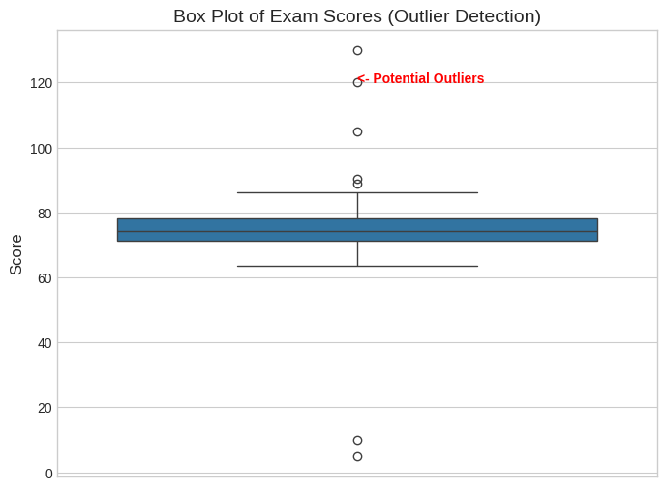

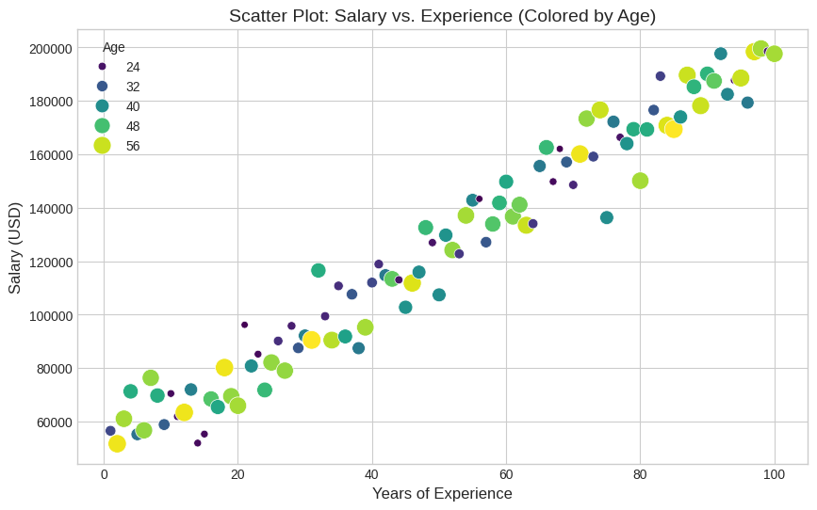

Experiment No. 4

Aim: Write a program to show various encoding methods used for ordinal data

Code:
import pandas as pd
from sklearn.preprocessing import LabelEncoder, OneHotEncoder

data_enc = pd.DataFrame({
'Education': ['High School', 'Bachelor', 'Master', 'PhD', 'Bachelor', 'High School', 'Master'],
'Salary': [40, 60, 80, 120, 65, 45, 85]
})

print("Original Data:\n", data_enc)

education_order = ['High School', 'Bachelor', 'Master', 'PhD']

print("\Custom Label Encoding ")
ordinal_map = {level: i for i, level in enumerate(education_order)}
data_enc['Education_Label_Encoded'] = data_enc['Education'].map(ordinal_map)

print(data_enc[['Education', 'Education_Label_Encoded']])

print("\n 2. One-Hot Encoding using Pandas get_dummies")
one_hot_encoded_df = pd.get_dummies(data_enc, columns=['Education'], prefix='Edu', dtype=int)

print(one_hot_encoded_df.filter(regex='^Edu_'))

Output:
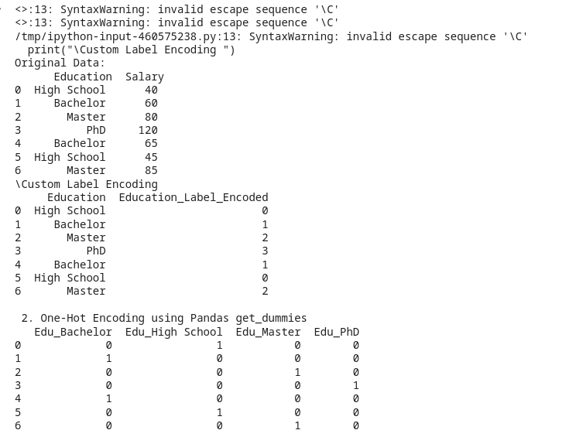

Experiment No. 5

Aim: Write a program to Normalize and standardize the data.

Code:
import pandas as pd
import numpy as np
from sklearn.preprocessing import MinMaxScaler, StandardScaler

data_scale = pd.DataFrame({
'Age': np.random.randint(20, 60, 10), # Range: 40
'Income': np.random.randint(50000, 150000, 10), # Range: 100,000
'Experience': np.random.randint(1, 30, 10) # Range: 29
})

print("Original Data (First 5 rows):\n", data_scale.head())

X = data_scale[['Age', 'Income', 'Experience']]

scaler_std = StandardScaler()
X_standardized = scaler_std.fit_transform(X)
X_standardized_df = pd.DataFrame(X_standardized, columns=[f'{col}_Standardized' for col in X.columns])

print("\n Standardized Data (Mean=0, StdDev=1")
print(X_standardized_df.describe().loc[['mean', 'std']])
print(X_standardized_df.head())

scaler_minmax = MinMaxScaler()
X_normalized = scaler_minmax.fit_transform(X)
X_normalized_df = pd.DataFrame(X_normalized, columns=[f'{col}_Normalized' for col in X.columns])

print("\n Normalized Data (Range [0, 1]) ")
print(X_normalized_df.describe().loc[['min', 'max']])
print(X_normalized_df.head())

Output:
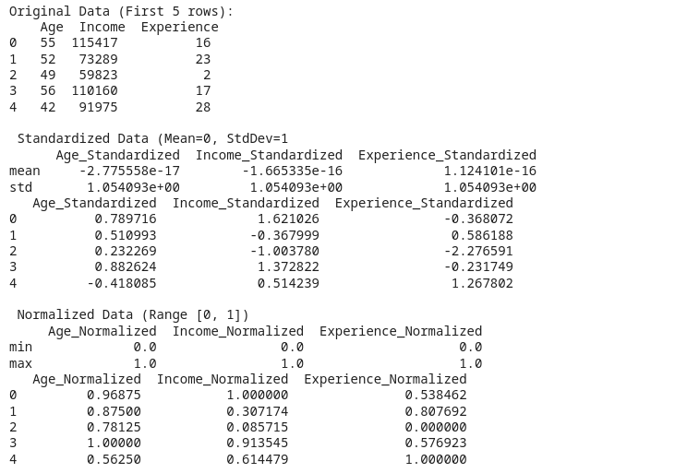

Experiment No. 6

Aim: Build a linear regression model to predict a continuous target variable and evaluate model performance using R-squared, MSE, and RMSE.

Code:
import pandas as pd
import numpy as np
from sklearn.model_selection import train_test_split
from sklearn.linear_model import LinearRegression
from sklearn.metrics import r2_score, mean_squared_error

np.random.seed(42)
X = np.arange(1, 101).reshape(-1, 1) # Years_Experience
y = 50000 + 3000 * X.flatten() + np.random.normal(0, 15000, 100) # Salary

X_train, X_test, y_train, y_test = train_test_split(
X, y, test_size=0.3, random_state=42
)

model_lr = LinearRegression()
model_lr.fit(X_train, y_train)

y_pred = model_lr.predict(X_test)

r_squared = r2_score(y_test, y_pred)

mse = mean_squared_error(y_test, y_pred)

rmse = np.sqrt(mse)

print("--- Linear Regression Model Evaluation ---")
print(f"Model Coefficient (Slope): {model_lr.coef_[0]:.2f}")
print(f"Model Intercept: {model_lr.intercept_:.2f}")

print("\nPerformance Metrics:")
print(f"R-squared (R2): {r_squared:.4f}")
print(f"Mean Squared Error (MSE): {mse:.2f}")
print(f"Root Mean Squared Error (RMSE): {rmse:.2f}")

example_experience = 15
predicted_salary = model_lr.predict(np.array([[example_experience]]))
print(f"\nPredicted Salary for {example_experience} years experience: ${predicted_salary[0]:,.2f}")

Output:
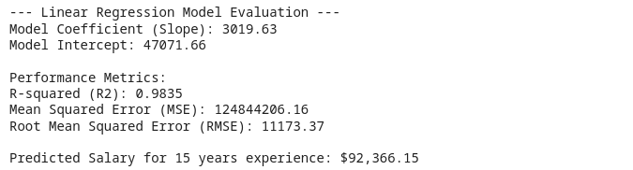

Experiment No. 7

Aim: Implement logistic regression for binary classification and Evaluate accuracy, sensitivity, and specificity.

Code:
import pandas as pd
import numpy as np
from sklearn.model_selection import train_test_split
from sklearn.linear_model import LogisticRegression
from sklearn.metrics import accuracy_score, confusion_matrix, roc_auc_score

np.random.seed(42)
N = 200
df_log = pd.DataFrame({
'Age': np.random.randint(20, 60, N),
'Income': np.random.randint(30000, 120000, N),
})
df_log['Purchase'] = ((df_log['Age'] > 40) & (df_log['Income'] > 75000)).astype(int)
df_log.loc[np.random.choice(df_log.index, 30, replace=False), 'Purchase'] = 1
df_log.loc[np.random.choice(df_log.index, 20, replace=False), 'Purchase'] = 0

X = df_log[['Age', 'Income']]
y = df_log['Purchase']

X_train, X_test, y_train, y_test = train_test_split(
X, y, test_size=0.3, random_state=42
)

model_log = LogisticRegression(solver='liblinear', random_state=42)
model_log.fit(X_train, y_train)

y_pred = model_log.predict(X_test)

accuracy = accuracy_score(y_test, y_pred)

cm = confusion_matrix(y_test, y_pred)
TN, FP, FN, TP = cm.ravel()

sensitivity = TP / (TP + FN)

specificity = TN / (TN + FP)

print("--- Logistic Regression Model Evaluation ---")
print(f"Accuracy: {accuracy:.4f}")
print("Confusion Matrix (CM):\n", cm)
print(f"\tTrue Positive (TP): {TP}")
print(f"\tTrue Negative (TN): {TN}")
print(f"\tFalse Positive (FP): {FP}")
print(f"\tFalse Negative (FN): {FN}")

print(f"\nSensitivity (Recall): {sensitivity:.4f} (Ability to predict positive class)")
print(f"Specificity: {specificity:.4f} (Ability to predict negative class)")

Output:
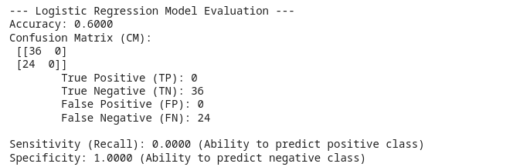

Experiment No. 8

Aim: Construct a decision tree for multi-class classification using various feature selection techniques.

Code:
import pandas as pd
from sklearn.datasets import load_iris
from sklearn.model_selection import train_test_split
from sklearn.tree import DecisionTreeClassifier
from sklearn.metrics import classification_report
from sklearn.feature_selection import SelectKBest, f_classif

iris = load_iris()
X = pd.DataFrame(iris.data, columns=iris.feature_names)
y = iris.target

X_train, X_test, y_train, y_test = train_test_split(
X, y, test_size=0.3, random_state=42
)

print("Original features:", list(X.columns))

k_best_features = 2
selector = SelectKBest(score_func=f_classif, k=k_best_features)
X_train_new = selector.fit_transform(X_train, y_train)
X_test_new = selector.transform(X_test)

selected_features = X_train.columns[selector.get_support()].tolist()
print(f"Selected Top {k_best_features} Features: {selected_features}\n")

model_dt = DecisionTreeClassifier(random_state=42)
model_dt.fit(X_train_new, y_train)

y_pred = model_dt.predict(X_test_new)

print("--- Decision Tree Classification Report (using selected features) ---")
print(classification_report(y_test, y_pred, target_names=iris.target_names))

print(f"The model was trained using only '{selected_features[0]}' and '{selected_features[1]}'.")

Output:
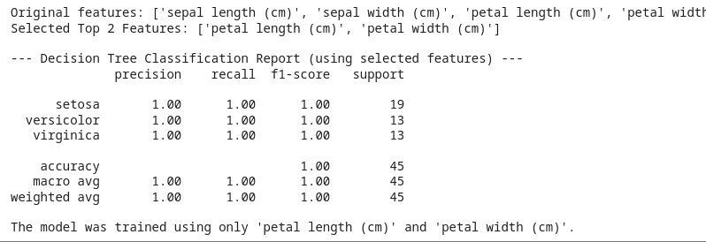

Experiment No. 9

Aim: Implement the k-means clustering Algorithm for a given dataset.

Code:
import pandas as pd
import numpy as np
import matplotlib.pyplot as plt
from sklearn.cluster import KMeans
from sklearn.datasets import make_blobs

X, y_true = make_blobs(
n_samples=300, centers=4, cluster_std=0.60, random_state=42
)
X = pd.DataFrame(X, columns=['Feature_A', 'Feature_B'])

k = 4
kmeans = KMeans(n_clusters=k, random_state=42, n_init=10)
kmeans.fit(X)
X['Cluster'] = kmeans.labels_
centroids = kmeans.cluster_centers_

print(f"K-Means Clustering performed with K={k}.")
print("\nCluster Centroids (Mean values of each feature per cluster):")
print(pd.DataFrame(centroids, columns=['Feature_A', 'Feature_B']))

plt.figure(figsize=(10, 7))

sns.scatterplot(
x='Feature_A', y='Feature_B', hue='Cluster', data=X,
palette=sns.color_palette("tab10", k), legend='full', s=70
)

plt.scatter(
centroids[:, 0], centroids[:, 1], marker='X', s=200,
color='red', label='Centroids', edgecolor='black'
)

plt.title(f'K-Means Clustering (K={k})', fontsize=14)
plt.xlabel('Feature A')
plt.ylabel('Feature B')
plt.legend(loc='lower right')
plt.show()

Output:
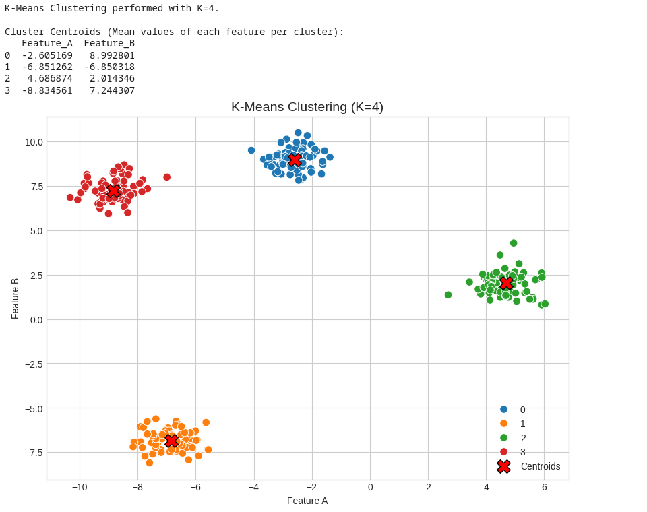

Experiment No. 10

Aim: Implement the DBSCAN Algorithm for a given dataset and explain how it can be used for outlier detection

Code:
import pandas as pd
import numpy as np
import matplotlib.pyplot as plt
from sklearn.cluster import DBSCAN
from sklearn.datasets import make_circles
from sklearn.preprocessing import StandardScaler
import seaborn as sns

X, _ = make_circles(n_samples=300, factor=0.5, noise=0.05, random_state=42)
X = StandardScaler().fit_transform(X) # Scaling is often important for distance-based algorithms

outliers = np.array([[2.5, 2.5], [-2.5, -2.5], [0, 2.5], [2.5, 0]])
X = np.vstack([X, outliers])
X_df = pd.DataFrame(X, columns=['X', 'Y'])

dbscan = DBSCAN(eps=0.3, min_samples=5)
dbscan.fit(X)
X_df['Cluster'] = dbscan.labels_

print("--- DBSCAN Clustering Results ---")
print("Number of detected clusters (excluding noise/outliers):", len(set(dbscan.labels_)) - (1 if -1 in dbscan.labels_ else 0))

outliers_count = (X_df['Cluster'] == -1).sum()
print(f"Number of Outliers detected (labeled -1): {outliers_count}")

plt.figure(figsize=(10, 7))

unique_clusters = X_df['Cluster'].unique()
cluster_markers = {cluster: 'o' if cluster != -1 else 'X' for cluster in unique_clusters}

sns.scatterplot(
x='X', y='Y', hue='Cluster', data=X_df,
palette='viridis', style='Cluster', markers=cluster_markers, s=100
)
plt.title('DBSCAN Clustering and Outlier Detection', fontsize=14)
plt.xlabel('X Coordinate')
plt.ylabel('Y Coordinate')
plt.legend(title='Cluster ID (-1 is Outlier)')
plt.show()

Output:
